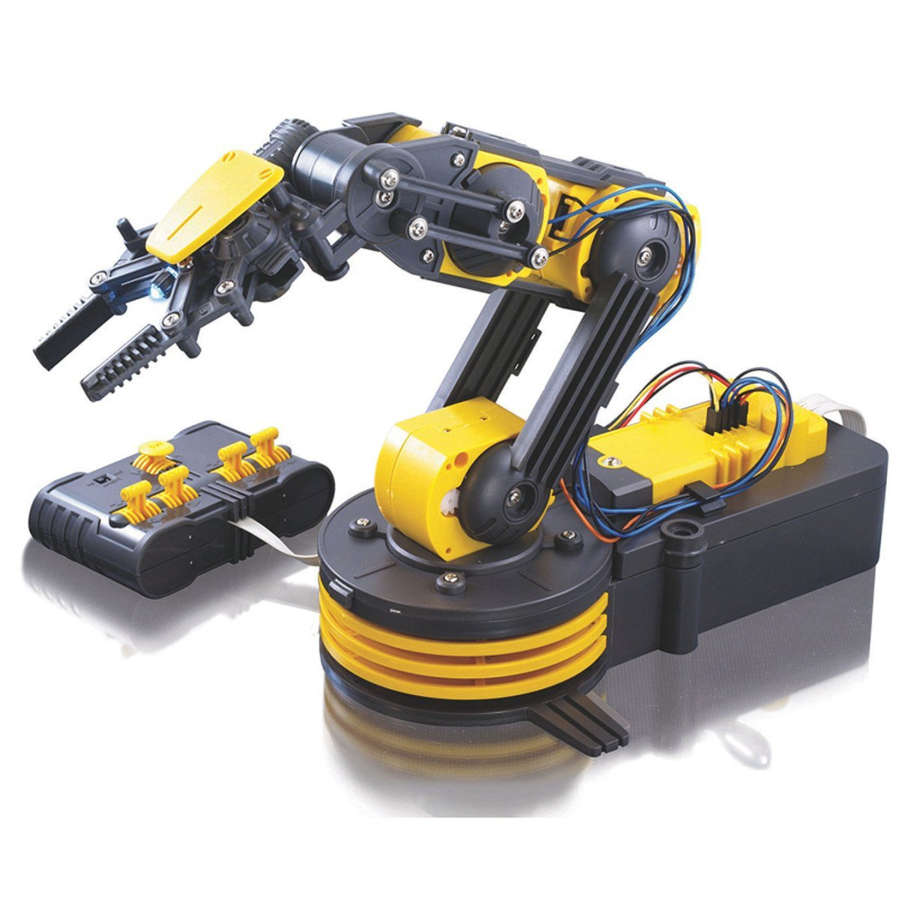Intro to Robotics with K-5th grade students

Figure 1: one robot arm built by UH roboticists

(30 minutes, 6 college roboticists, 22 students)

Supply Kits:

1. 6 robot arms (see image)
2. 18 Duplo building blocks.
3. Manila Folders with pictures of block arrangements & forward and inverse kinematics.
4. Spinners to choose random shape
5. Posttest
6. Pens for posttest

## Activity 1 (6 min): meet the robot arm, learn concepts “Degrees of Freedom” and “workspace”

Setup one robot arm at each table. Distribute 3-4 students to each table.

DO NOT TURN THE ROBOT ARM ON YET. IT IS TOO EXCITING, SO WAIT TILL END.

Roboticists introduce “*Degrees of Freedom*”, and point them out to the students:

***Degrees of Freedom = number of joints***

**Robot** arms are described by their **degrees of freedom**. This number typically refers to the number of single-axis rotational joints in the arm, where higher number indicates an increased flexibility in positioning a tool.

Roboticists ask students questions:

* What is a robot?
* How could you add more “Degrees of Freedom” to this robot? What “Degrees of Freedom” would you add to make your robot better?
* How would you change the robot?
* What area can the robot reach? (Introduce concept of ‘workspace’)

Roboticists introduce “*Workspace*”, and show it to the students:

***Workspace = area robot can reach***

**Workspace** of a manipulator is the total volume swept out by the end effector as the manipulator executes all possible motions.

## Activity 2 (6 min): Control the human robot (forward kinematics –in terms of joint angles)

1. Place 3 blocks on the table.
2. Select one student who will give commands for the roboticist’s shoulder, one for the elbow, one for the wrist, one for the hand. Student can say “shoulder up”/”shoulder down”, etc.
3. Roboticist closes eyes, and students pick one block for the roboticist to grab
4. Practice this activity twice, moving the blocks once the roboticist closes their eyes.

## Activity 3 (6 min): Control the human robot (inverse kinematics – in terms of table position)

1. Place 3 blocks on the table.
2. Roboticist closes eyes, and students pick one block for the roboticist to grab
3. Students command “move hand forward/backward, left/right, up/down
4. Practice this activity twice, moving the blocks once the roboticist closes their eyes.

## Optional Activity 4 (6 min): programming a robot

1. Place 3 blocks on the table.
2. Select one student who is the ‘robot’
3. Spin the spinner to choose the Duplo shape to create
4. Students must give commands to their robot, but cannot touch the robot or the blocks
5. Switch student who is the robot and repeat.

## Optional Activity 5 (6 min): Have students stack cubes using robot arm

1. Power on robot arm and demonstrate how it works, and to avoid ‘clicking’ noises when the arm reaches range limits
2. Ensure each student gets a turn, explore the robot

## Metric: take posttest

1. All students need a pen
2. Read the questions aloud, answer student questions

## Activity 6 (4 min): show the NASA Swarmathon robot

1. Show robot, roboticist explains the contest rules (quickly)
2. Take a picture with the NASA swarmathon robot

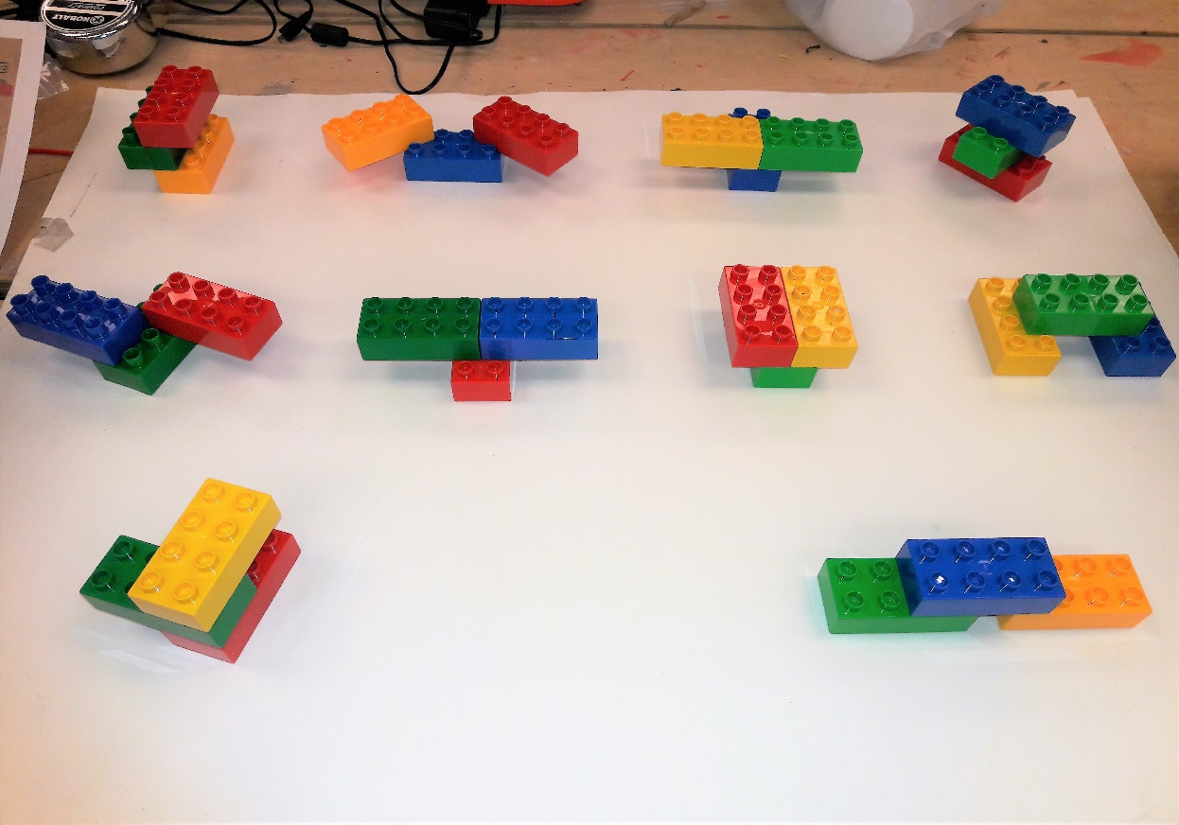

(4)

(0)

(2)

(1)

(3)

(6)

(5)

(8)

(7)

(9)

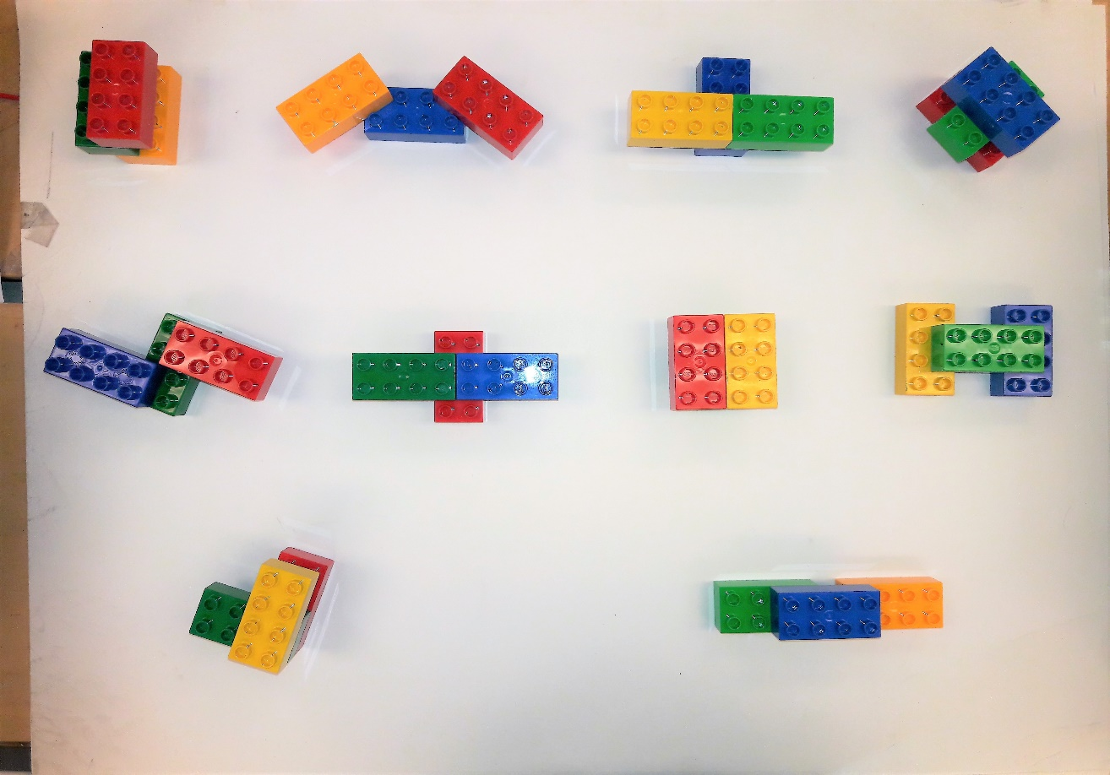

(0)

(1)

(2)

(3)

(4)

(5)

(6)

(7)

(8)

(9)

## Optional Activity 4 (6 min): programming a robot. Place 3 blocks on the table.

1. Select one student who is the ‘robot’
2. Spin the spinner to choose the Duplo shape to create
3. Students must give commands to their robot, but cannot touch the robot or the blocks (first time, have the roboticist give directions)
4. Switch student who is the robot and repeat.

­­­

Turn waist more/less

Shoulder

Bend/unbend

Elbow

Bend/unbend

Hand

Open/close

Control the Joints

“Forward Kinematics”

Hand: forward/backward

Hand: up/down

Hand: left/right

Hand

Open/close

Control the hand

“Inverse Kinematics”